**Assignment: 5**

1. Write a Java program to create and run a thread by extending the Thread class. The thread should print "Hello from Thread" five times.

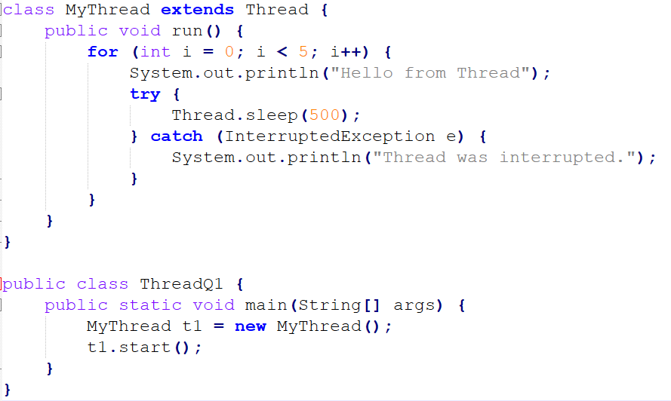

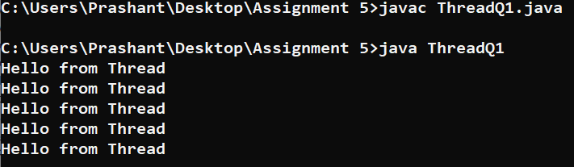

1. Write a Java program to create and run a thread by implementing the Runnable interface. The thread should print numbers from 1 to 5.

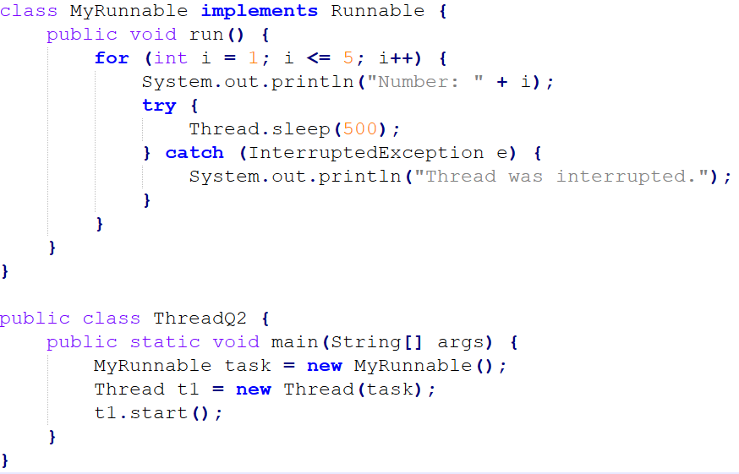

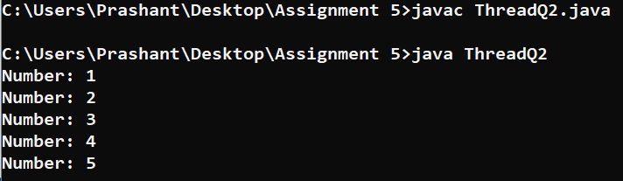

1. Write a Java program where the main thread prints "Main Thread Running" and a child thread prints "Child Thread Running". Run them simultaneously.

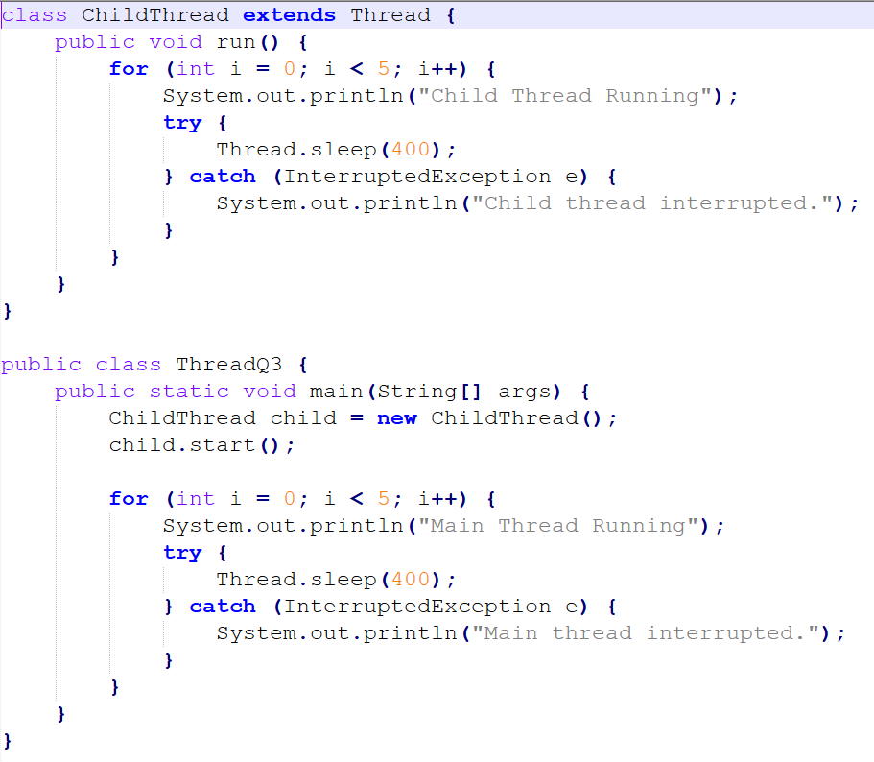

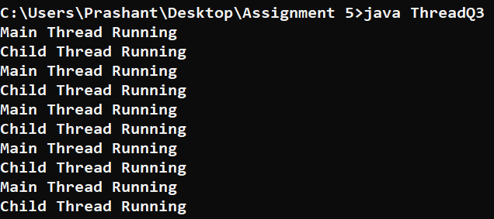

1. Write a Java program to demonstrate the use of setName() and getName() methods for threads.

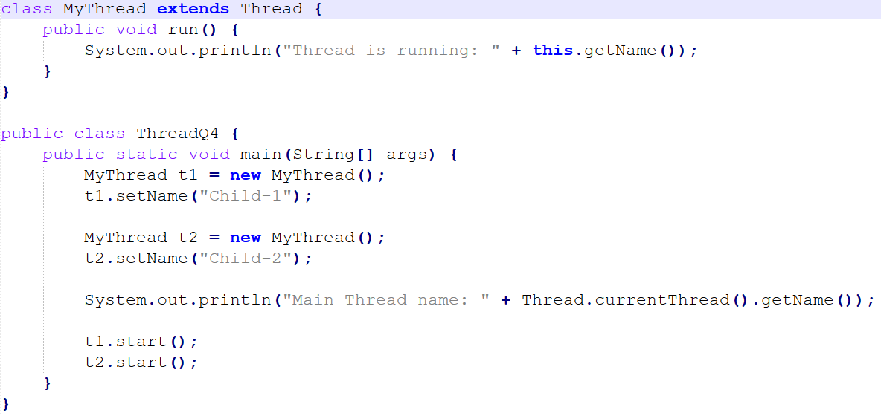

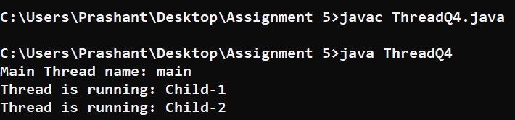

1. Write a Java program to demonstrate the use of setPriority() and getPriority() methods by creating two threads with different priorities.

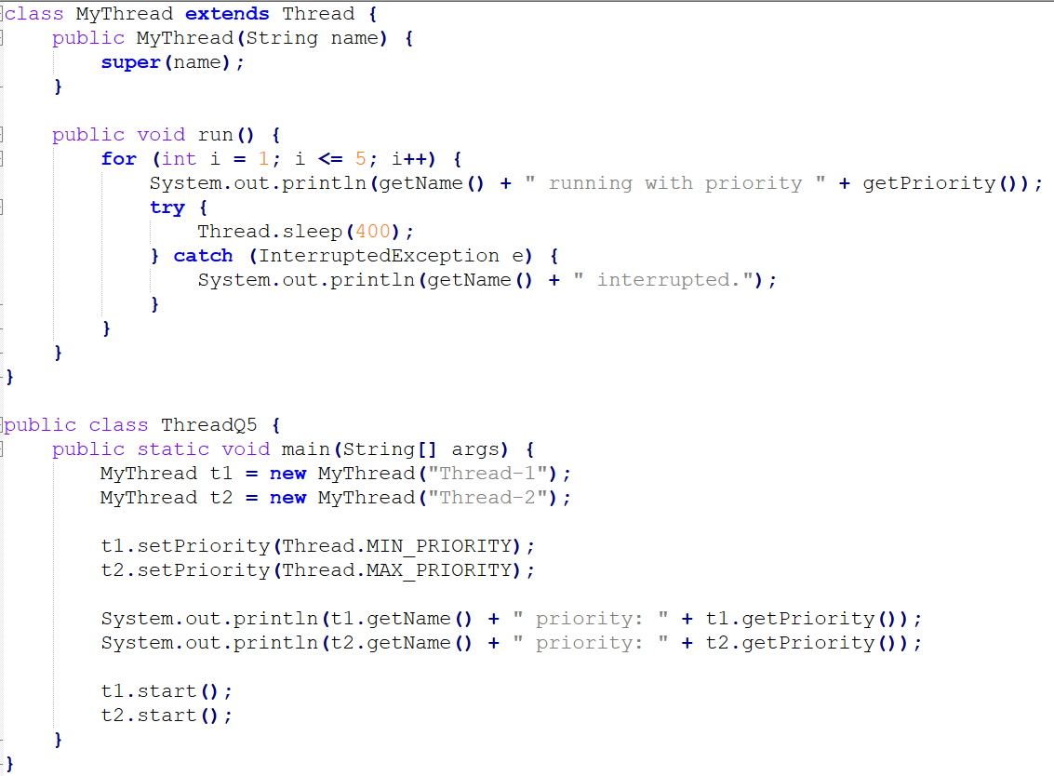

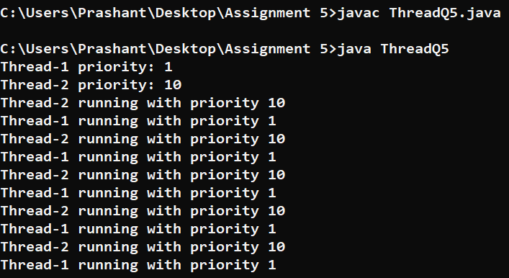

1. Write a Java program where one thread prints numbers from 1 to 10, and another thread prints numbers from 11 to 20.

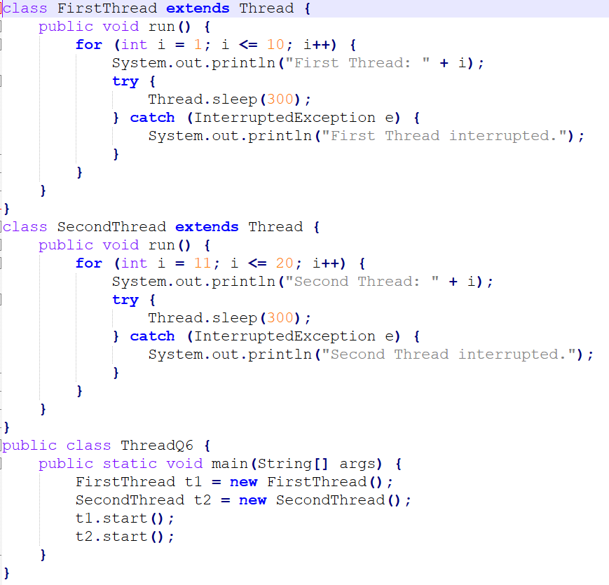

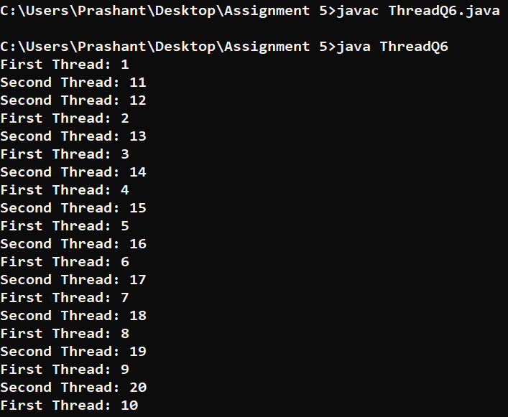

1. Write a Java program to demonstrate the use of the sleep() method by pausing a thread for 1 second after printing each number.

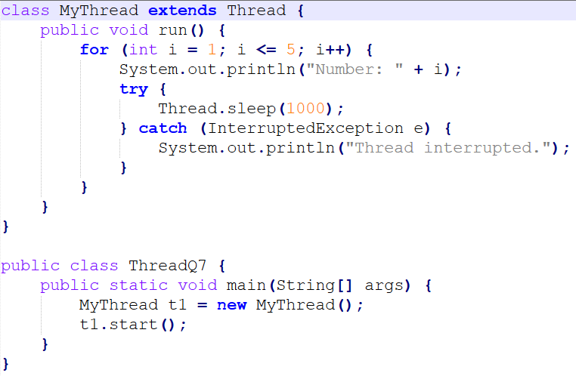

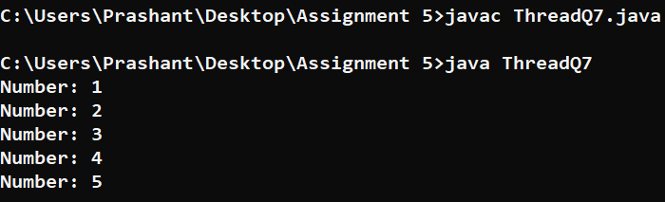

1. Write a Java program where the main thread waits for a child thread to finish using the join() method.

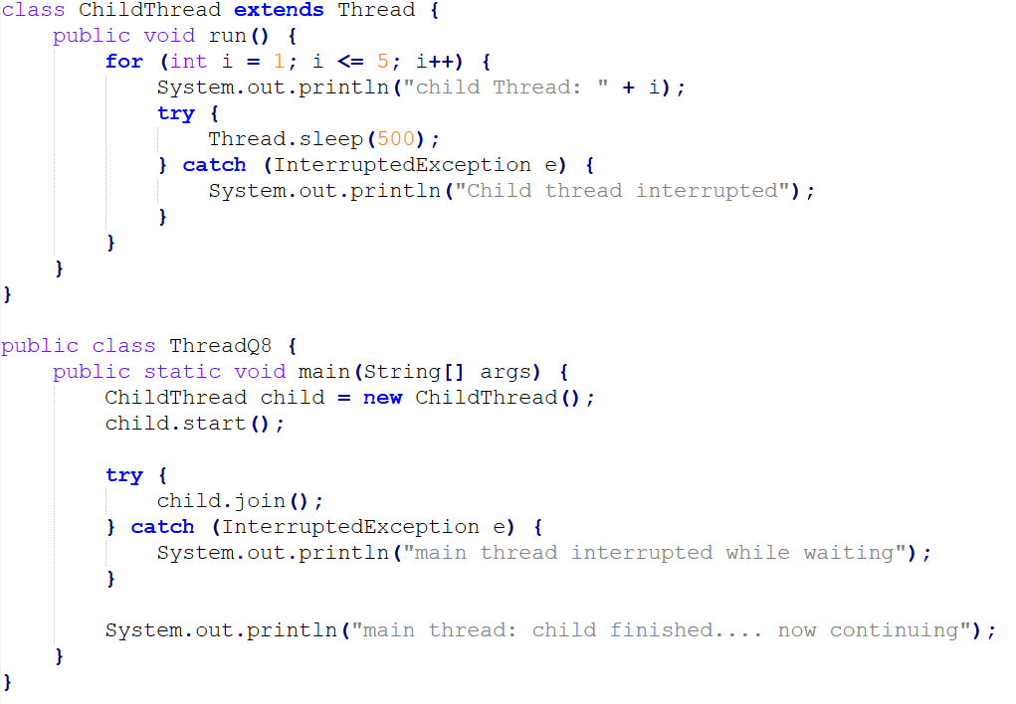

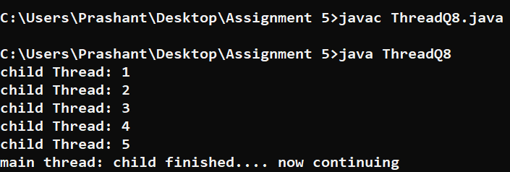

1. Write a Java program to check whether a thread is alive or not using the isAlive() method.

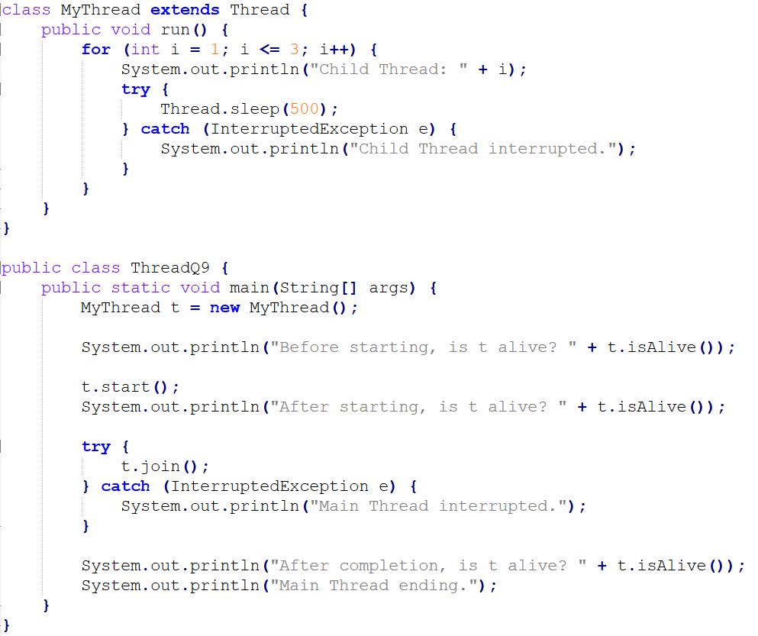

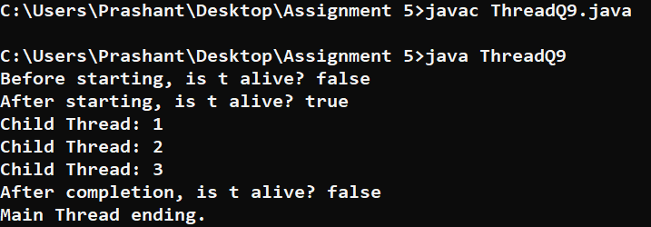

1. Write a Java program to create two threads:

● Thread 1 prints "Good Morning" 5 times.

● Thread 2 prints "Welcome" 5 times.

Run both threads simultaneously.

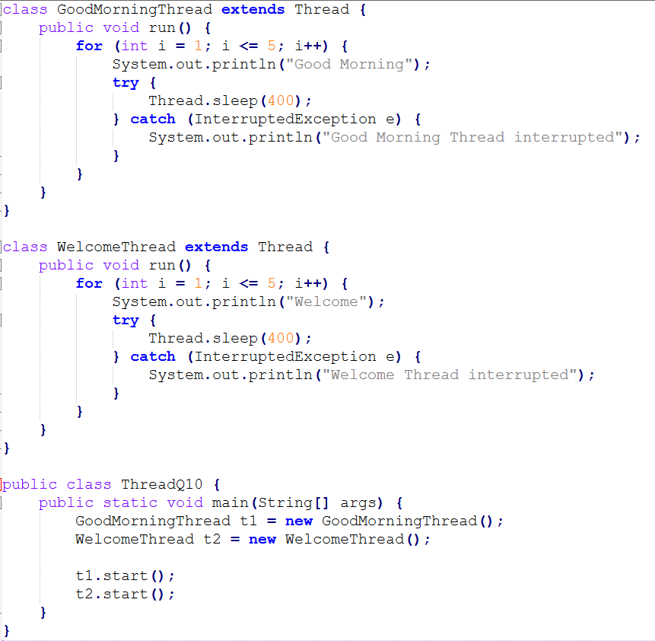

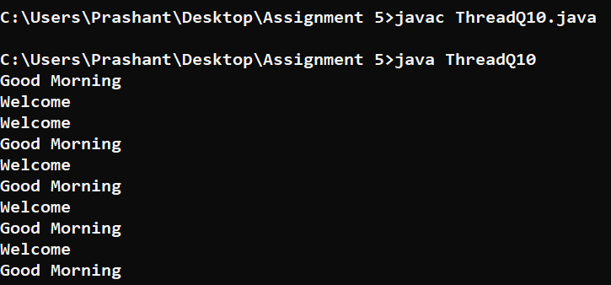

1. Write a Java program where one thread prints even numbers from 2 to 20, and another thread prints odd numbers from 1 to 19.

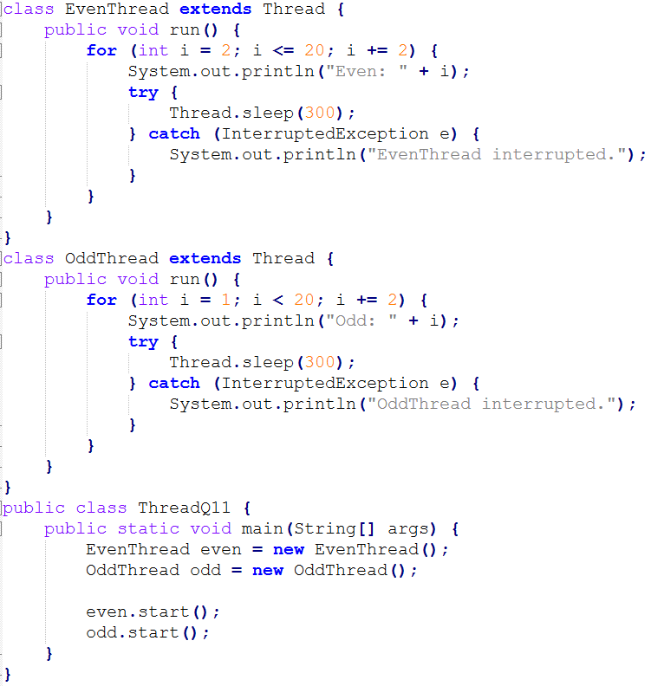

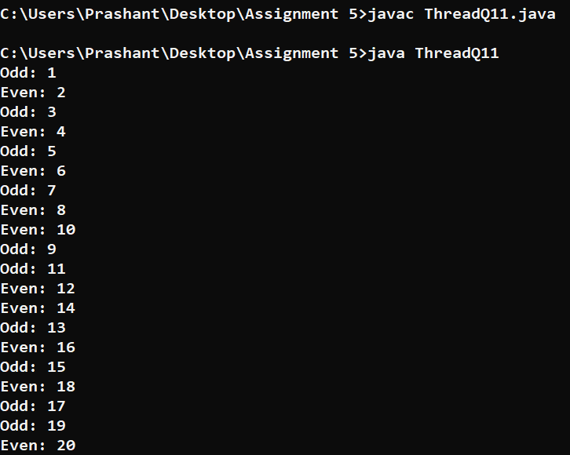

1. Write a Java program to create three threads. Each thread should print its own message 3 times.

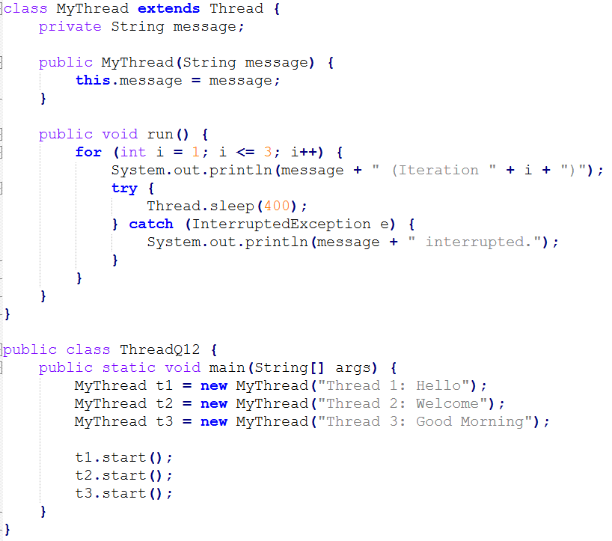

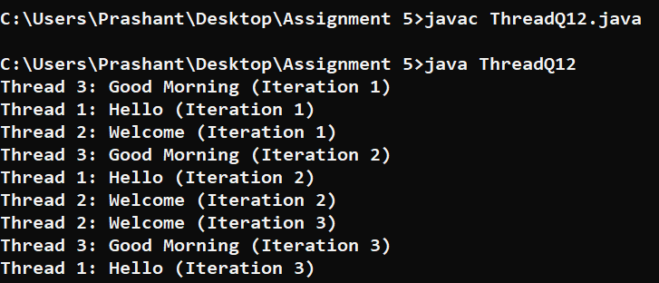

1. Write a Java program to demonstrate the difference between calling run() directly and calling start() on a thread.

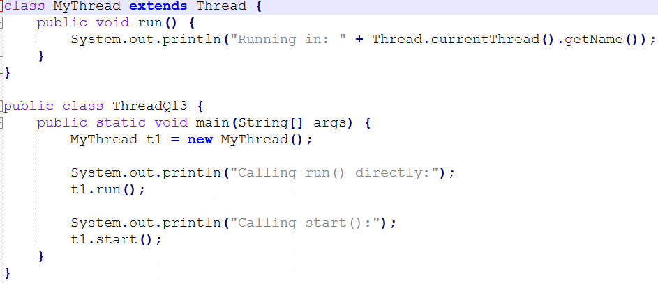

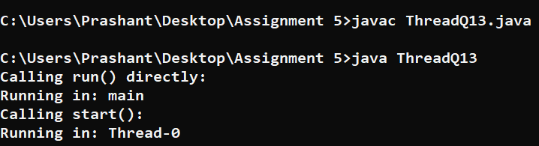

1. Write a Java program to create a thread that calculates the sum of numbers from 1 to 100.

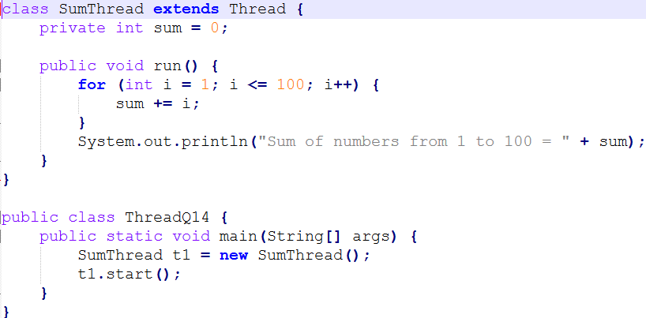

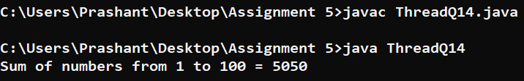

1. Write a Java program to demonstrate how to stop a thread gracefully using a boolean flag instead of the deprecated stop() method.

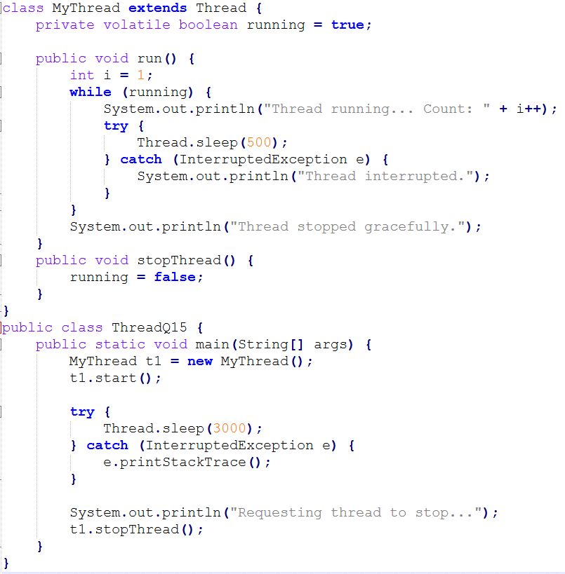

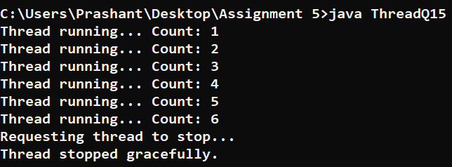

1. Write a Java program where one thread prints the lowercase alphabet (a to z), and another thread prints the uppercase alphabet (A to Z).

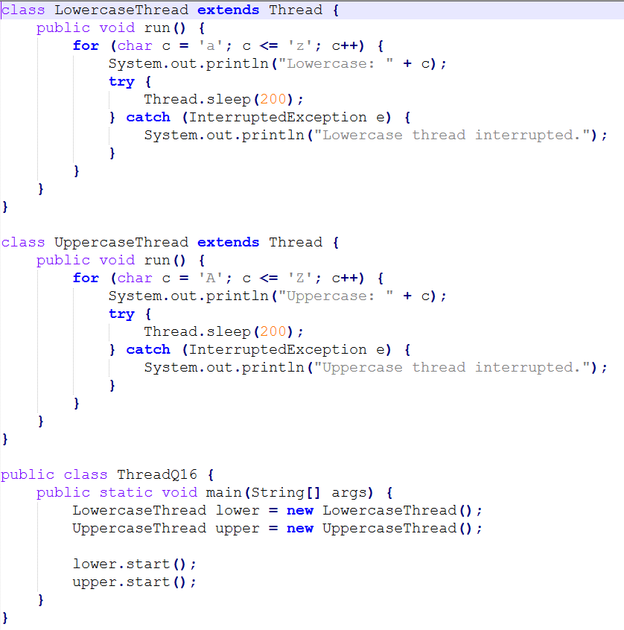

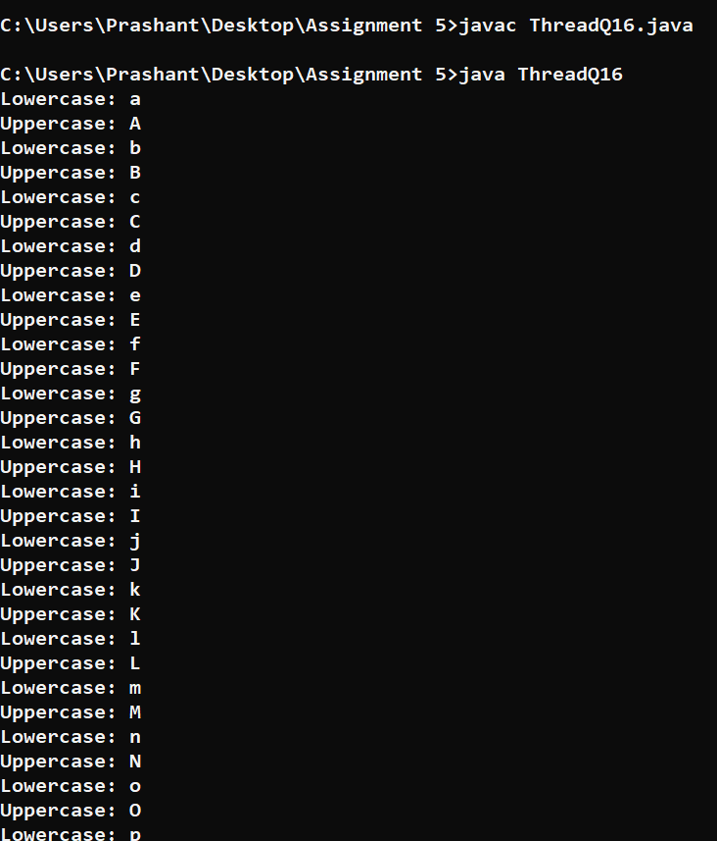

1. Write a Java program to demonstrate how multiple threads can access a shared counter variable. Show the problem of race condition (without synchronization).

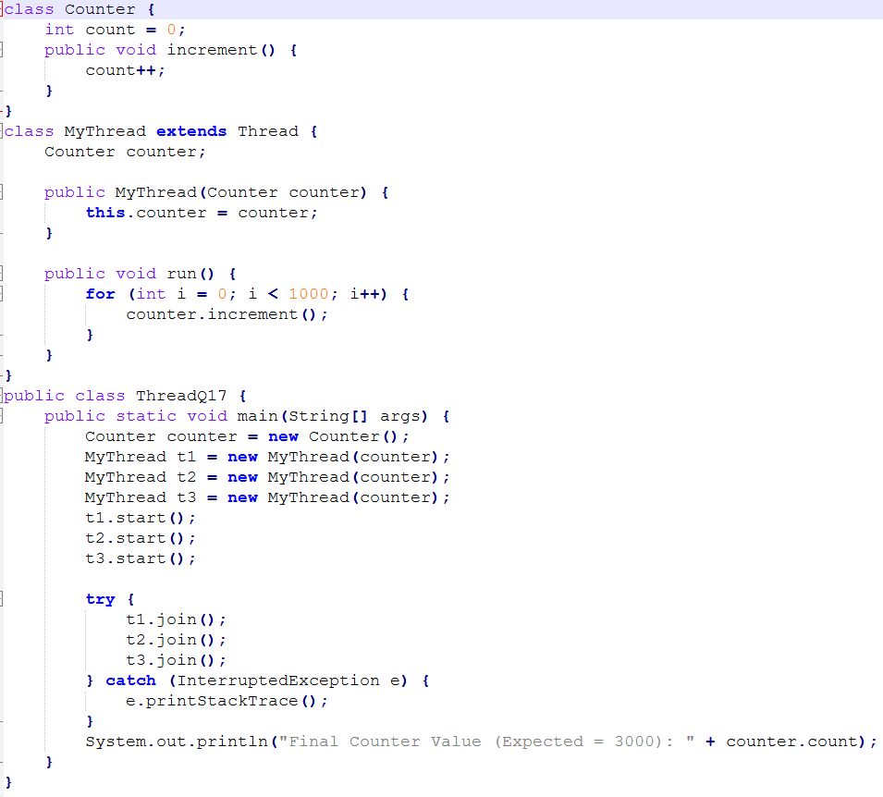

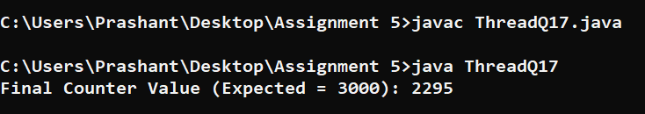

1. Write a Java program to demonstrate synchronization by using the synchronized keyword on a method that increments a counter.

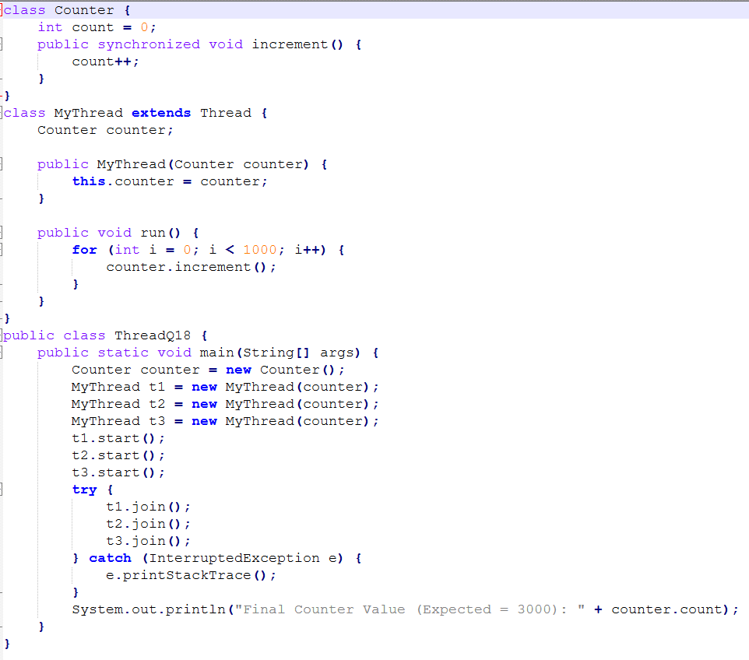



1. Write a Java program to create a thread that prints the current time every 2 seconds, five times.

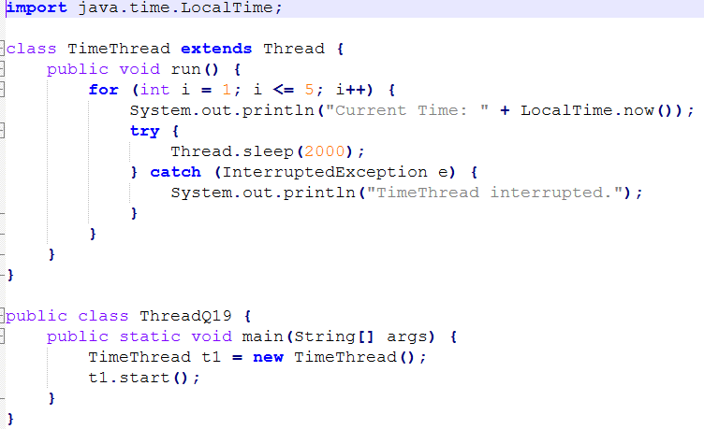

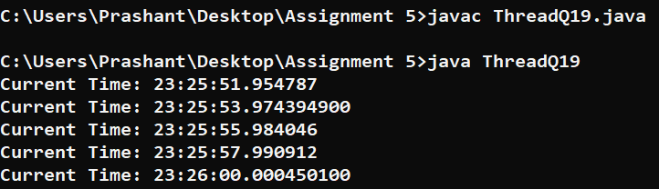

1. Write a Java program where two threads run in parallel:

● The first thread prints "Learning Java" 5 times.

● The second thread prints "Multithreading in action" 5 times.

